|  |  |
| --- | --- |
| **\\VFILERDPI\DPI-Home\OBRIENR2\My Documents\Downloads\PP logo.jpg** |  |
| **CONSENT CONDITIONS – Coastal Protection Works**  NORTHERN REGIONAL PLANNING PANEL | |

|  |  |
| --- | --- |
| PANEL REFERENCE & DA NUMBER | PSNTH-264 Byron Shire Council DA 10.2023.287.1 |
| PROPOSAL | Coastal Protection Works, in the form of an extension to an existing geobag wall.  The extension would be approx. 40m long and comprise approx. 200 x 0.75m3 geobags arranged in a stepped profile, 5 units high and 2 units wide.  The extension is proposed as a temporary structure, with a life of 5 years, pending completion of Council’s Coastal Management Program for the area.  The proposal is defined as *beach and coastal restoration works* and is permitted in the site’s 7(f1) Coastal Lands zoning. |
| ADDRESS | Lot 1 DP1215893  144 Bayshore Drive, Byron Bay |
| APPLICANT | Applicant: Ms Kate Singleton, Planners North  Owner: Ganra Pty Ltd |
| APPLICATION TYPE | Integrated Development |
| DETERMINATION DATE |  |
| CONSENT TO OPERATE FROM |  |
| CONSENT TO LAPSE ON |  |

**SCHEDULE 1. CONDITIONS**

**PART A: GENERAL**

**A1 Approved Plans and Supporting Documentation**

The geobag coastal protection works must be implemented in accordance with the approved plans, specifications and supporting documentation listed below, which have been endorsed by Council’s approved stamp, except where amended by conditions of this consent:

|  |  |  |  |
| --- | --- | --- | --- |
| **Title** | **Version No.** | **Drawn by** | **Dated** |
| General Arrangement and Location Plan | PA3267-RHD-00-XX-DR-ME-1000 P02 | Royal HaskoningDHV | 29.05.2023 |
| Cross Sections Sheet 1 | PA3267-RHD-00-XX-DR-ME-1101 P02 | Royal HaskoningDHV | 29.05.2023 |
| Cross Sections Sheet 2 | PA3267-RHD-00-XX-DR-ME-1102 P02 | Royal HaskoningDHV | 29.05.2023 |
| Cross Sections Sheet 3 | PA3267-RHD-00-XX-DR-ME-1103 P02 | Royal HaskoningDHV | 29.05.2023 |
| Re-Establishment of Dune Profile Sheet 1 | PA3267-RHD-00-XX-DR-ME-1104 P01 | Royal HaskoningDHV | 29.05.2023 |
| Re-Establishment of Dune Profile Sheet 2 | PA3267-RHD-00-XX-DR-ME-1105 P01 | Royal HaskoningDHV | 29.05.2023 |
| Re-Establishment of Dune Profile Sheet 3 | PA3267-RHD-00-XX-DR-ME-1106 P01 | Royal HaskoningDHV | 29.05.2023 |
| Elements of Byron – Extension to Existing Geobag Coastal Protection Works  Coastal Engineering Assessment | PA3267-IB-RP-221121 | Royal HaskoningDHV | 29.05.2023 |
| Construction Methodology Statement  Geo-Bag Wall Extension |  | Lockyer Valley Quarry Solutions | 24.06.2024 |

In the event of any inconsistency between conditions of this approval and the drawings/documents referred to above, the conditions prevail. In the event of any inconsistency between the approved plans and the supporting documentation, the approved plans prevail.

Reason: To ensure the development proceeds in the manner assessed by Council and all parties are aware of the approved plans and supporting documentation that applies to the development.

**A2 Time Limited Consent**

The geobag coastal protection works must be removed by the 5th anniversary of the determination date of the development consent or on the Minister’s certification of Council’s adopted Coastal Management Program, whichever is sooner. Removal of the geobag coastal protection works must be undertaken in accordance with the approved Geobag Coastal Protection Works Removal Plan (Condition B3).

If at any time before the 5th anniversary of the determination date of the development consent, Council forms the opinion that there has been a significant failure of the geobag coastal protection works and/or associated works due to coastal processes, and it is not considered by Council to be feasible to repair or reinstate the works due to impacts from coastal processes on the beach and dunal system, the geobag coastal protection works must be removed in accordance with the Geobag Coastal Protection Works Removal Plan (Condition B3) at the landowners’ expense.

Reason: To ensure that the geobag coastal protection works can be removed and replaced by a permanent coastal management arrangement as identified and adopted in a Coastal Management Program, prepared and certified under the provisions of the *Coastal Management Act 2016*.

**A3 Bond for Removal of Geobag Coastal Protection Works**

Prior to the issue of a Construction Certificate, a suitable bond or bank guarantee is to be provided to Council for the removal of the geobag coastal protection works and reinstatement of the dune in accordance with Conditions A2 and B3.

The bond amount must be 150% of the cost of works and three (3) quotes must be provided for the future removal of these works and all activities associated with dune restoration.

The bond estimate must include all costs, including engineering supervision, appropriate permits, the number of truck movements / loads required, dust mitigation, disposal costs and the restoration of the dune and surrounding area, and any damage to Council’s roads and infrastructure.

Upon acceptance of the bond amount, Council will arrange an invoice for the agreed amount.

The bond must be paid prior to the issue of a Construction Certificate.

Council will use the bond to remove the geobag coastal protection works in the event that Condition A2 is not complied with.

Reason: To ensure that the geobag coastal protection works will be removed if and when required.

**A4 Integrated Approvals from other State Government Approval Bodies**

This development consent includes an Integrated development approval under Sections 4.46 and 4.47 of the *Environmental Planning and Assessment Act 1979*, being a Controlled Activity approval under the *Water Management Act 2000* (WM Act), and is subject to the General Terms of Approval from the Department of Planning and Environment - Water dated 15 August 2024 contained in **Schedule 3** of this Notice of Determination.

**PART B: PRIOR TO THE ISSUE OF A CONSTRUCTION CERTIFICATE**

**B1 Monitoring and Management / Maintenance Plan**

A Monitoring and Management / Maintenance Plan shall be prepared and approved by Council prior to the issue of a Construction Certificate, documenting measures to be employed to monitor and address erosion in the vicinity of the geobag coastal protection works.

The Plan must be prepared in accordance with the outline provided in Section 4 of the letter from Royal HaskoningDHV dated 14 May 2014 (PA3267-RHD-XX-XX-CO-X-0001) and must include (as a minimum):

1. Monitoring at a 3-monthly frequency and following storms, including UAV imagery, survey, photographic monitoring and dune condition inspections.
2. Provisions relating to the import of sand and/or beach scraping (subject to gaining relevant licences/approvals) to address end effect impacts on beach and dune form and revegetation (and fencing as necessary) to restore dune vegetation values.
3. Monitoring and management of continued safe public access to and along the foreshore.
4. Provisions for the repair of damaged coastal protection works, removal of the coastal protection works in the event of failure and reinstatement of dune values above and immediately adjacent/over the structure following an erosion event.
5. Requirements for regular reporting to be provided to Council.

The Plan shall provide for the restoration of the beach and land adjacent to the beach, including the public accessway to the beach located to the north (if required). Any maintenance or restoration works carried out outside the subject site, must be subject to a Cape Byron Marine Parks Permit and Crown Land Licence.

Reason: To ensure the development does not adversely impact on the coastal environment, and biodiversity.

**B2 Soft Stabilisation Works**

To avoid a net loss of sand from the proposed geobag coastal protection work, 800m3 of sand must be imported into the site to assist in the re-establishment of the dune and to offset sand lock-up anticipated to occur over the 5-year lifespan of the geobag coastal protection works.

Plans submitted with the application for Construction Certificate must indicate the origin of the imported sand, temporary stockpile locations within the site and the application of the sand to the geobag wall.

Reason: To ensure that an additional supply of sand is available to the beach compartment in the case of future erosion events.

**B3 Geobag Coastal Protection Works Removal Plan**

Prior to the issue of a Construction Certificate, the applicant must prepare and submit to Council a Geobag Coastal Protection Works Removal Plan documenting the methodology and timeframes for removal of the works.

The Removal Plan must be endorsed by Council’s Director Sustainable Environment & Economy (or delegate) prior to the issue of a Construction Certificate.

The objective of this plan is to outline the process for decommissioning the geobag coastal protection works and rehabilitating the land. It must consider a range of beach state scenarios that may exist at the time at which the geobag structure is removed.

It must include, but not be limited to, the following:

1. Expected timeline for geobag removal and site rehabilitation ensuring that all works can be removed on or before the timeframe specified in Condition A2 of this consent;
2. A requirement for the landowner to advise Council in writing of the commencement of the removal works in advance of the commencement of any associated works;
3. Details of site rehabilitation;
4. Details of waste management and recycling of all materials arising from the decommissioning; and
5. Expected maintenance period for areas disturbed by the geobag removal process including any landscaping and vegetation that needs to be replaced and re-established. A minimum of 3 months is anticipated.

Reason: To ensure the removal of the geobag coastal protection works occurs in an orderly manner and that the amenity of the area is maintained while the structure is being decommissioned, and to ensure the site is rehabilitated and maintained for a reasonable period after the geobags have been removed.

**B4 Dune Revegetation Plan**

A Dune Revegetation Plan, prepared by a suitably qualified ecologist, is to be submitted to and approved by Council prior to the issue of a Construction Certificate. The Plan must demonstrate that the revegetation works will provide suitable habitat for the critically endangered Beach Stone Curlew, Pied Oyster Catcher (endangered) and Little Tern (endangered).

Reason: To ensure that revegetation works enhance local biodiversity values.

**B5 Security Deposit**

Before the commencement of any works on the site or the issue of a construction certificate, the applicant must make all of the following payments to Council and provide written evidence of these payments to the certifier:

|  |  |
| --- | --- |
| Security deposit | $10,000 |
| Inspection fee | $215 |

The payments will be used for the cost of:

* making good any damage caused to the geobag coastal protection works or any adjoining land should the landowner fail to implement the approved Monitoring and Management / Maintenance Plan in a timely manner, and
* any inspection carried out by Council in connection with the completion of the work or the making good any damage.

Reason: To ensure that any required repairs and/or maintenance are carried out during the life of the structure.

**B6 Waste Management Plan**

Before the issue of a construction certificate, the applicant is to ensure that a waste management plan is prepared in accordance with the EPA’s Waste Classification Guidelines and the following requirements before it is provided to and approved by the certifier:

1. Council’s Waste Management Development Control Plan

OR

1. details the following:

* the contact details of the person(s) removing the waste
* an estimate of the waste (type and quantity) and whether the waste is expected to be reused, recycled or go to landfill
* the address of the disposal location(s) where the waste is to be taken

The applicant must ensure the waste management plan is referred to in the environmental management plan and kept on-site at all times during construction.

Reason: To ensure that construction wastes are appropriately managed.

**B7 Construction Site Management Plan**

Before the issue of a construction certificate, the applicant must ensure a construction site management plan is prepared and approved by the certifier. The plan must include the following matters:

* location and materials for protective fencing and hoardings to the perimeter on the site
* provisions for public safety
* pedestrian and vehicular site access points and construction activity zones
* details of construction traffic management, including proposed truck movements to and from the site and estimated frequency of those movements, and measures to preserve pedestrian safety in the vicinity of the site
* protective measures for on-site tree preservation (including in accordance with AS 4970-2009 Protection of trees on development sites and Council’s DCP, if applicable) and trees in adjoining public domain (if applicable)
* details of any bulk earthworks to be carried out
* location of site storage areas and sheds
* equipment used to carry out all works
* a garbage container with a tight-fitting lid
* dust, noise and vibration control measures
* location of temporary toilets.

The applicant must ensure a copy of the approved construction site management plan is kept on-site at all times during construction.

Reason: To ensure that construction activities are appropriately managed.

**B8 Section 7.12 Levy to be Paid**

Prior to the issue of a construction certificate the section 7.12 levy required by the Byron Developer Contributions Plan 2012 must be paid to Council.

The levy will be calculated as follows:

Levy payable = %C x $C

* %C is the levy rate applicable as set out in the latest Ministerial Direction issued under section 7.17.
* $C is the proposed cost of carrying out the development.

The rate of %C is:

|  |  |
| --- | --- |
| Proposed cost of the development | Maximum percentage of the levy |
| Up to $100,000 | Nil |
| $100,001–$200,000 | 0.5 percent |
| More than $200,000 | 1.0 percent |

The cost of development must be calculated in accordance with clause 25J of the Regulation. The Cost Summary Report (copy attached) as set out in schedule 2 of the Section 7.12 contributions plan must be submitted to Council with the payment. The cost summary report must be prepared by a quantity surveyor. Copies of Cost Summary Report are available at Council’s main office or may be downloaded from Council’s website.

Reason: To ensure developer contributions are paid.

**B9 Long Service Levy to be Paid**

In accordance with Section 6.8 of the Environmental Planning and Assessment Act 1979 (as amended), a Construction Certificate for SUBDIVISION WORKS OR BUILDING WORKS shall NOT be issued until any Long Service Levy payable under Section 34 of the Building and Construction Industry Long Service Payments Act, 1986 (or where such levy is payable by instalments, the first instalment of the levy) has been paid (as applicable).

These payments can be made online at [www.longservice.nsw.gov.au](http://www.longservice.nsw.gov.au). Proof of payment is required to be submitted with the Construction Certificate application. For further information regarding the Long Service Payment please refer to the website above.

Reason: To ensure Long Service Levy for Construction Workers is paid.

**PART C: PRIOR TO CONSTRUCTION WORK COMMENCING**

**C1 Erosion and Sediment measures**

Erosion and sedimentation controls are to be in place in accordance with the *Guidelines for Erosion & Sediment Control on Building Sites*. Particular attention is to be given to the provision of the following sediment and erosion control measures:

a. Temporary driveway from the edge of road to the building site;

b. Temporary downpipes immediately installed after the roof has been erected;

c. Silt fence or sediment barrier.

**Sediment and erosion control measures must be maintained at all times until the site has been stabilised by permanent vegetation cover or hard surface.**

**Note: Council may impose on-the-spot fines for non-compliance with this condition.**

**Any such measures that are deemed to be necessary because of the local conditions must be maintained at all times until the site is made stable (i.e. by permanent vegetation cover or hard surface).**

Reason: To ensure that erosion and sedimentation are installed.

**C2** **Toilet facilities**

Toilet facilities are to be provided, at or in the vicinity of the work site at the rate of one toilet for every 20 persons or part of 20 persons employed at the site. Each toilet provided must be a toilet connected to an accredited sewage management system approved by the Council or be a building and construction site portable chemical toilet.

Only one (1) such portable chemical toilet may be used during construction, should additional toilets be required during the construction they must be either:

1. Connected to an accredited sewage management system approved by the Council. or
2. Not installed or used until such time that approval under Section 68 of the Local Government Act 1993 is obtained for the installation of a human waste storage facility.

Note: The chemical toilet must be installed and serviced by a licensed contractor (including pump-outs)

Reason: To provide appropriate amenities for construction workers are provided.

**PART D: CONSTRUCTION CONDITIONS**

**D1 Construction Hours**

The principal certifier must ensure that building work, demolition or vegetation removal is only carried out between:

* 7am to 6pm on Monday to Friday.
* 8am to 1pm on Saturday.

The principal certifier must ensure building work, demolition or vegetation removal is not carried out on Sundays and public holidays, except where there is an emergency.

Unless otherwise approved within a construction site management plan, construction vehicles, machinery, goods or materials must not be delivered to the site outside the approved hours of site works.

**Note:** Any variation to the hours of work requires Council’s approval.

Reason: To ensure the amenity of the area is maintained during construction works.

**D2 Construction Noise**

While building work is being carried out, and where a noise and vibration management plan is approved under this consent, the applicant must ensure that any noise generated from the site is controlled in accordance with the requirements of that plan.

**OR**

While building work is being carried out and where no noise and vibration management plan is approved under this consent, the applicant is to ensure that any noise caused by demolition, vegetation removal or construction does not exceed an LAeq (15 min) of 5dB(A) above background noise, when measured at any lot boundary of the property where the construction is being carried out.

Reason: To ensure the amenity of the area is maintained during construction works.

**D3 Sediment and Erosion Control**

Appropriate sedimentation and erosion controls must be installed and maintained at all times during any maintenance operations to limit impacts on adjacent vegetation, Belongil Beach and the Belongil Estuary.

Reason: To ensure the water quality of the area is maintained during construction works.

**D4 Biodiversity Protection and Management**

Existing trees and native vegetation on the site are to be retained and protected from damage during initial construction and during any subsequent maintenance work, with the exception of trees that have died or collapsed onto the beach. Dead or collapsed tree removal shall be carried out by an appropriately qualified person to avoid any risk to life or damage to property and must have with adequate public liability insurance.

In order to protect the biodiversity values that remain on the subject land, the following shall be complied with:

* No native trees are to be cleared for this development. Trees that have been severely damaged or killed by coastal erosion can be used for dune stabilization or relocated into adjacent areas of habitat
* All native vegetation used in rehabilitation areas is to be endemic to Byron Bay
* If a marine turtle nest is identified within 30 metres of a work area then it must be notified to NPWS and advice obtained on measures to avoid and mitigate any impacts from proposed works
* If a shorebird nest is identified within 30 metres of a work area then it must be notified to NPWS and advice obtained on measures to avoid and mitigate any impacts from proposed works
* If unexpected protected or threatened fauna are encountered, then work must stop immediately, and a qualified ecologist or wildlife carer must be contacted and relevant fauna spotter/catcher protocols must be followed to prevent harm to wildlife
* All machinery is to be clean prior to entering the subject land to ensure that weed seeds and propagules are not imported
* Contingencies are required to address the risk of bushfire, including spark arrestors and suspending works in high bushfire danger periods.

Reason: To protect biodiversity on the site.

**D5** **Visual Impact and Beach Amenity**

Dune stabilisation and restoration works or maintenance shall use screening and dune forming fencing material with sandy, earth or green tones to reduce visual impacts.

Any screening or dune forming material currently in use that is not sandy, earth or green tones will be replaced.

Reason: To ensure screening and fencing does not impact unnecessarily on the scenic amenity of the locality.

**D6 Signs to be erected on the works sites**

A sign must be erected in a prominent position on the work site:

a. stating that unauthorised entry to the work site is prohibited, and

b. showing the name of the person in charge of the work site and a telephone number at which that person may be contacted outside working hours.

Any such sign is to be removed when the work has been completed.

Reason: To protect the public during construction work.

**D7 Prevention of water pollution**

Only clean and unpolluted water is to be discharged to Council’s stormwater drainage system or any watercourse to ensure compliance with the Protection of Environment Operations Act.

**Note: Council may impose on-the-spot fines for non-compliance with this condition.**

Reason: To ensure the water quality of the local waterways is maintained during construction works.

**D8 Discovery of Aboriginal Objects**

While any work is being carried out, all such works must cease immediately if an Aboriginal object is unexpectedly discovered. The applicant must notify Heritage NSW, BoBBAC and Byron Shire Council immediately.

In this condition: “Aboriginal object” means any deposit, object or material evidence (not being a handicraft made for sale) relating to the Aboriginal habitation of the area that comprises New South Wales, being habitation before or concurrent with (or both) the occupation of that area by persons of non-Aboriginal extraction and includes Aboriginal remains.

Reason: To ensure the protection of Aboriginal objects of potential significance during works.

**D9 Discovery of Contamination**

Should any contaminated, scheduled, hazardous or asbestos containing material be discovered before or during works, the applicant and contractor shall ensure the appropriate regulatory authority is notified and that such material is contained, encapsulated, sealed, handled or otherwise disposed of to the requirements of such Authority.

Reason: To ensure contamination discovered during construction is dealt with as quickly as possible and to protect the health of the community and the environment.

**D10 Red Fire Ants**

Prior to the use of materials and equipment that have travelled through or from a biosecurity zone, the proponent shall ensure that contractors supply the necessary certificates for any of the materials and equipment.  The biosecurity zones are shown at the NSW DPI Alert [https://www.dpi.nsw.gov.au/biosecurity/insect-pests/fire-ants](https://aus01.safelinks.protection.outlook.com/?url=https%3A%2F%2Fwww.dpi.nsw.gov.au%2Fbiosecurity%2Finsect-pests%2Ffire-ants&data=05%7C02%7Crvaniersel%40byron.nsw.gov.au%7Cb4804f92159d496f94d508dcdb5a4e67%7C1026594f56234e7ca8a464c29791f2d9%7C0%7C0%7C638626428129458862%7CUnknown%7CTWFpbGZsb3d8eyJWIjoiMC4wLjAwMDAiLCJQIjoiV2luMzIiLCJBTiI6Ik1haWwiLCJXVCI6Mn0%3D%7C0%7C%7C%7C&sdata=Nlpd4wTxkXP2OONI7F8kUvJRJHOS37GG4VMFhK2Ym%2Fg%3D&reserved=0).

If red imported fire ants are suspected at or adjoining the works areas, work must stop immediately, and the following undertaken:

* Suspicious sightings of red imported fire ants or their mounds that have been identified within a site must be reported to NSW Department of Primary Industries immediately
* If red imported fire ants are suspected, do not disturb the ants or nests and make records of the ants and nest (including photographic record) as outlined in the NSW DPI Alert [https://www.dpi.nsw.gov.au/biosecurity/insect-pests/fire-ants](https://aus01.safelinks.protection.outlook.com/?url=https%3A%2F%2Fwww.dpi.nsw.gov.au%2Fbiosecurity%2Finsect-pests%2Ffire-ants&data=05%7C02%7Crvaniersel%40byron.nsw.gov.au%7Cb4804f92159d496f94d508dcdb5a4e67%7C1026594f56234e7ca8a464c29791f2d9%7C0%7C0%7C638626428129529625%7CUnknown%7CTWFpbGZsb3d8eyJWIjoiMC4wLjAwMDAiLCJQIjoiV2luMzIiLCJBTiI6Ik1haWwiLCJXVCI6Mn0%3D%7C0%7C%7C%7C&sdata=XNZlXLyxDcO3xEwdjn0dbeanlZVgv6WEOHuf6tirE70%3D&reserved=0)

If red imported fire ants are suspected at or adjoining the works areas, works may not commence until:

* DPI will work with the National Fire Ants Eradication Program to search the surrounding areas, treat the ants, and stop their spread, at no cost to the owners or occupiers.

Reason: To assist in halting the spread of ref fire ants.

**PART E: PRIOR TO THE ISSUE OF AN OCCUPATION CERTIFICATE**

**E1 Certification**

At the completion of works, an Occupation Certificate is to be issued by the Principal Certifying Authority (PCA).

Prior to issuing the Occupation Certificate, the PCA is to be provided with certification from Royal HaskoningDHV to the effect that the geobag coastal protection works have been constructed in accordance with their report “Elements of Byron – Extension to Existing Geobag Coastal Protection Works Coastal Engineering Assessment” (PA3267-IB-RP-221121) dated 29 May 2023.

Reason: To ensure that the works have been constructed in accordance with approved plans and specifications.

**E2 Works to be completed prior to issue of a Final Occupation Certificate**

All of the works indicated on the plans and approved by this consent, including any other consents that are necessary for the completion of this development, are to be completed and approved by the relevant consent authority/s prior to the issue of a Final Occupation Certificate.

Reason: To ensure all works are complete.

**E3 Works Location Survey**

A final survey of the geobag wall is to be submitted to Council demonstrating that all parts of the structure are wholly within the property boundary and no aspect of the wall encroaches into the adjoining Coastal Reserve.

Reason: To ensure that the works do not impact on the adjoining Cape Byron Marine Park.

**PART F: DURING THE LIFE OF THE GEOBAG COASTAL PROTECTION WORKS**

**F1 Monitoring and Management/ Maintenance Plan**

The approved Monitoring and Management / Maintenance Plan shall be implemented for the full 5-year term of the consent. Implementation of the approved plan, and any costs associated with it, shall be the responsibility of the landowner.

Reason: To ensure that the land owner continues to maintain the works for the life of this approval.

**F2 Tree Loss Offset**

Any loss of trees associated with end effects erosion associated with the geobag coastal protection works must be offset by additional planting at a rate of 5 new trees for each tree lost, with appropriate tree species to be planted within nearby areas of littoral rainforest.

Reason: To offset the impacts of tree loss caused by the approved works.

**SCHEDULE 2. PRESCRIBED CONDITIONS**

The prescribed conditions in accordance with Division 2, Subdivision 1 of the Environmental Planning and Assessment Regulation 2021 as at the date of this development consent as are of relevance to this development must be complied with.

Refer to the [*Environmental Planning and Assessment Regulation 2021*](https://legislation.nsw.gov.au/view/html/inforce/current/sl-2021-0759#pt.4-div.2-sdiv.1), *Division 2, Subdivision 1* of for full text of the above clauses. This can be accessed at <http://www.legislation.nsw.gov.au>.

**SCHEDULE 3. INTEGRATED DEVELOPMENT GENERAL TERMS OF APPROVAL**

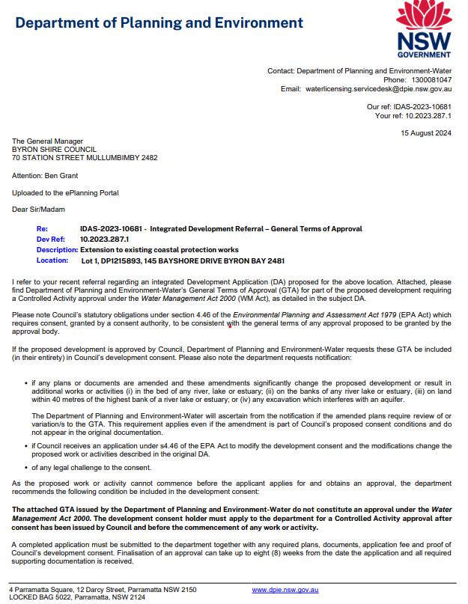

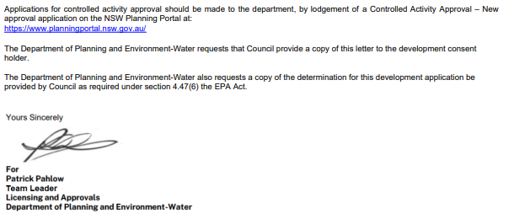

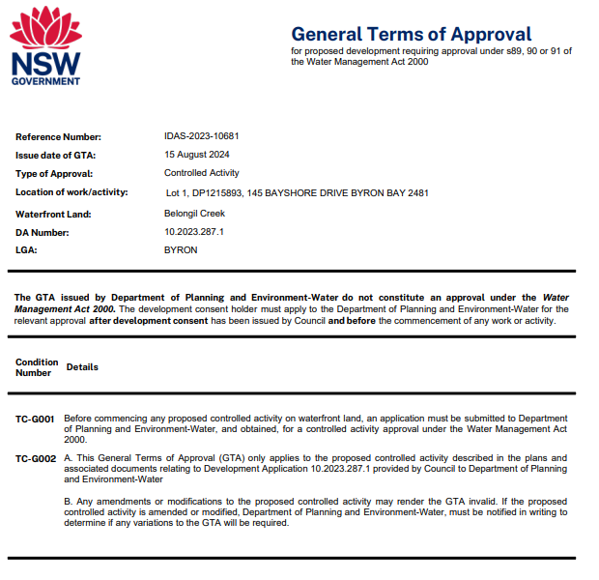

**SCHEDULE 4. NOTES**

|  |
| --- |
| **Coastal Management Program**  The landowner should work with Council and relevant State Government Agencies in the preparation of a Coastal Management Program to develop long-term strategies to address coastal erosion at the site. |
| **Construction Certificate required:**  This development consent is issued under the Environmental Planning and Assessment Act 1979 and does not relate to structural aspects or specifications of the building under the Building Code of Australia. All buildings and alterations require the issue of a Construction Certificate prior to works commencing.  Application for a Construction Certificate must be made online using the [NSW Planning Portal](https://www.planningportal.nsw.gov.au/post-consent-certificates/construction-certificate). |
| **Principal Certifying Authority:**  Work must not commence until the applicant has:-  a. appointed a Principal Certifying Authority (if the Council is not the PCA); and  b. given Council at least two days notice of the intention to commence the erection of the building. Notice must be given by using the prescribed ‘Form 7’.  c. notified the Principal Certifying Authority of the Compliance with Part 6 of the Home Building Act 1989. |
| **Occupation Certificate required:**  The building must not be occupied until the Principal Certifying Authority has issued an Occupation Certificate. |
| **Protection of the Environment Operations Act 1997:**  It is an offence under the provisions of the Protection of the Environment Operations Act 1997 to act in a manner causing, or likely to cause, harm to the environment. Anyone allowing material to enter a waterway or leaving material where it can be washed off-site may be subject to a penalty infringement notice (“on-the-spot fine”) or prosecution. |
| **Penalties apply for failure to comply with development consents**  Failure to comply with conditions of development consent may lead to an on the spot fine being issued pursuant to section 4.2(1) of the Environmental Planning & Assessment Act 1979 or prosecution pursuant to section 9.50 of the Environmental Planning & Assessment Act 1979. |
| **Relics Provisions- Advice**  Attention is directed to the NSW Heritage Act 1977 and the provisions of the Act in relation to the exposure of relics.  The Act requires that if:   1. a relic is suspected, or there are reasonable grounds to suspect a relic in ground, that is likely to be disturbed damaged or destroyed by excavation; and/or 2. any relic is discovered in the course of excavation that will be disturbed, damaged or destroyed by further excavation;   Those responsible for the discovery must notify nominated management personnel who will in turn notify the Heritage Council of New South Wales or its delegate, the Office of Environment and Heritage, NSW Heritage Branch, and suspend work that might have the effect of disturbing, damaging or destroying such relic until the requirements of the NSW Heritage Council have been satisfied (ss139, 146). |
| **Fire Ants**  The importation of any of the following material from Queensland invasive ant biosecurity zones must be in accordance with the [Biosecurity (Invasive Ant Carriers) Control Order 2023](https://www.google.com/url?sa=t&rct=j&q=&esrc=s&source=web&cd=&cad=rja&uact=8&ved=2ahUKEwjRq7GB6qGCAxXRBYgKHUvwDQIQFnoECA4QAQ&url=https%3A%2F%2Fwww.dpi.nsw.gov.au%2F__data%2Fassets%2Fpdf_file%2F0010%2F1449199%2FBiosecurity-Invasive-Ant-Carriers-Control-Order-2023.pdf&usg=AOvVaw3Tc53noL50USkQO977YVIx&opi=89978449) (including any revised orders made under the Biosecurity Act 2015) and meet the requirements of NSW Department of Primary Industries:   * organic mulch (which includes manure, bark, wood chips, hay, straw, sileage, and sugar cane bagasse); * baled materials; * potted plants; * agricultural or earth-moving machinery; * fill or soil (which includes anything with soil on it such as turf); and * mining or quarrying materials.   Prior to the importation of each material type, the supplier must provide the receiver and the Principal Certifying Authority with the relevant Certificate as identified within the Biosecurity (Invasive Ant Carriers) Control Order 2023 or revised biosecurity control orders. All material shall meet the requirements of the relevant Certificate.  It is an offence under the Biosecurity Act 2015 if this material comes from within five kilometres of a known invasive ant infested area (e.g. identified Fire Ant Biosecurity Zones in Queensland), or any other place at which the person knows, or ought reasonably to know, that an invasive ant has been detected, unless the carrier material has been managed and treated to reduce the risk and meets the certification requirements listed in the Control Order. |